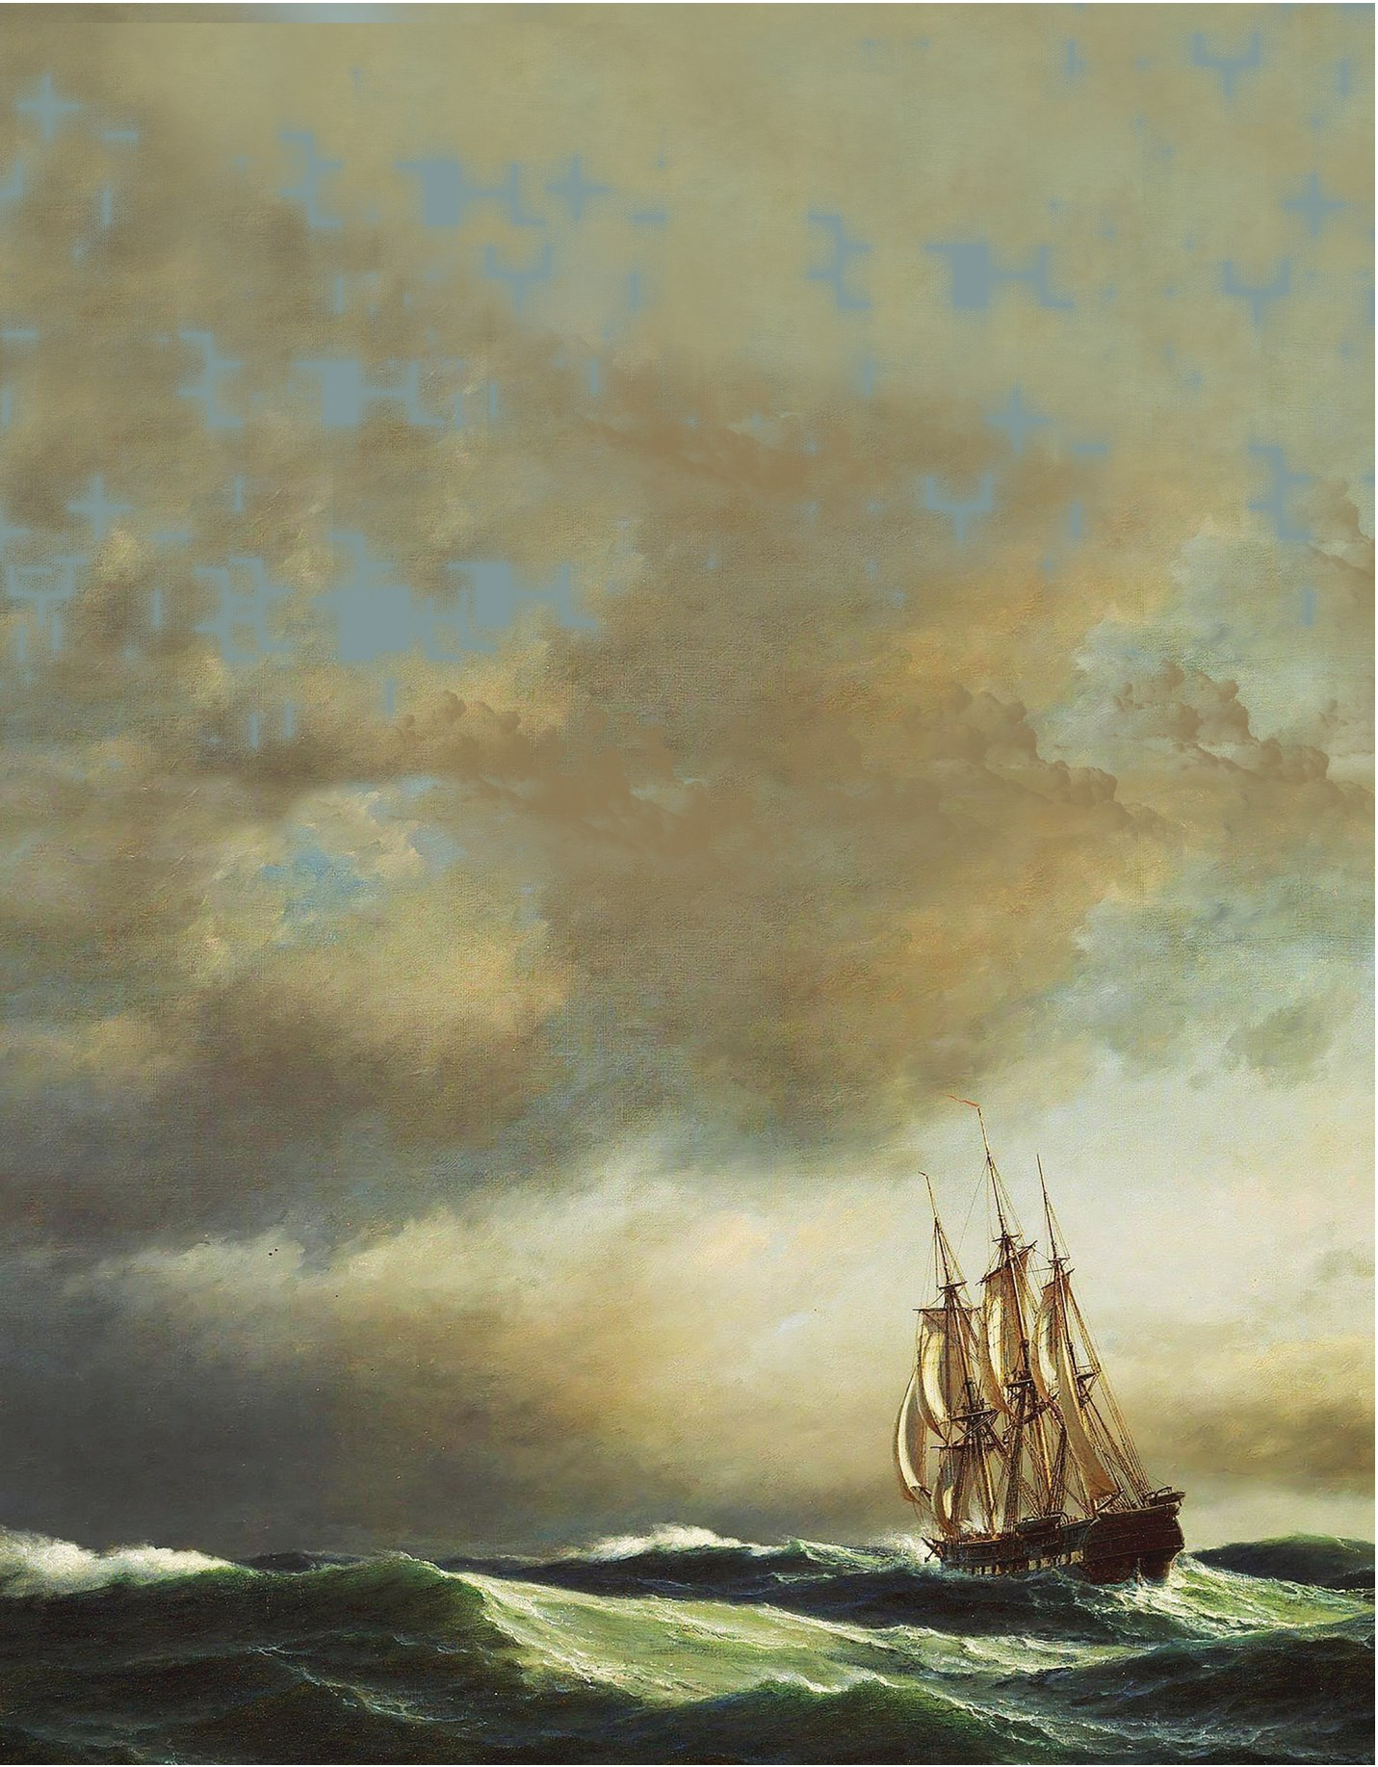

1 Life* Henry Van Dyke Poem

Let me but live my life from year to year, With forward face and unreluctant soul; Not hurrying to, nor turning from the goal; Not mourning for the things that disappear In the dim past, nor holding back in fear From what the future veils; but with a whole And happy heart, that pays its toll
To Youth and Age, and travels on with cheer.

So let the way wind up the hill or down,
O'er rough or smooth, the journey will be joy: Still seeking what I sought when but a boy, New friendship, high adventure, and a crown, My heart will keep the courage of the quest, And hope the road's last turn will be the best.

17

10th English_Unit_1.indd 17 28-11-2022 18:18:47

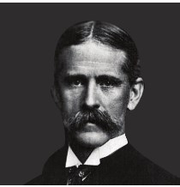
About the Poet



Henry Van Dyke (1852 – 1933) was an American author, poet, educator, and clergyman. He served as a professor of English literature at Princeton University between 1899 and 1923. He was elected to the American Academy of Arts and Letters and received many other honours.

mourning (v) -veils (v) -

crown (n) -quest (n) -
unreluctant* (adj.) -
feeling or expressing great sadness
to hide or cover something so that you cannot see it clearly or understand it
a prize or position offered for being the best
a long search for something that is difficult to find
willing to do something (*This form is generally not used but
the poet has coined it for emphasis)

The word sonnet is derived from the Italian word “sonetto,” which means a ‘little song’ or ‘small lyric’. In poetry, a sonnet has 14 lines, and is written in 'iambic pentameter' (A line with ten syllables, accented on every second beat). The first eight lines of a sonnet is known as “octave” and the last six lines is known as “sestet”. Sonnets can be categorized on the basis of their rhyme scheme.
Sonnet

A. Read the following lines from the poem and answer the questions that follow.


1. Let me but live my life from year to year, With forward face and unreluctant soul;
a. Whom does the word ‘me’ refer to?
b. What kind of life does the poet want to lead?

2. Not hurrying to, nor turning from the goal; Not mourning for the things that disappear
a. Why do you think the poet is not in a hurry? b. What should one not mourn for?

3. In the dim past, nor holding back in fear From what the future veils; but with a whole And happy heart, that pays its toll
To Youth and Age, and travels on with cheer.

a. What does the poet mean by the phrase ‘in the dim past’?
b. Is the poet afraid of future? c. How can one travel on with cheer?

18

10th English_Unit_1.indd 18 28-11-2022 18:18:47

4. So let the way wind up the hill or down,
O'er rough or smooth, the journey will be joy: Still seeking what I sought when but a boy, New friendship, high adventure, and a crown,
a. How is the way of life?
b. How should be the journey of life? c. What did the poet seek as a boy?

5. My heart will keep the courage of the quest, And hope the road's last turn will be the best.
a. What kind of quest does the poet seek here? b. What is the poet’s hope?

6. In the dim past, nor holding back in fear From what the future veils; but with a whole And happy heart, that pays its toll
To Youth and Age, and travels on with cheer.

a. Identify the rhyming words of the given lines.

7. Let me but live my life from year to year, With forward face and unreluctant soul; Not hurrying to, nor turning from the goal; Not mourning for the things that disappear
a. Identify the rhyme scheme of the given lines.

B. Answer the following question in about 80 – 100 words

1. Describe the journey of life as depicted in the poem by Henry Van Dyke.

C. Based on your understanding of the poem, complete the following passage by the using the phrases given in the box.

youth to old age up or down the hill to hurry nor move away high adventure joyful mourn looking ahead

The poet wants to live his life __________, willing to do something. He neither wants __________from his goal. He does not want to _______ the things he has lost, not hold back for fear of the future. He instead prefers to live his life with a whole and happy heart which cheerfully travels from __________. Therefore, it does not matter to him whether the path goes __________, rough or smooth, the journey will be __________. He will continue to seek what he wanted as a boy - new friendship, __________ and a crown (prize). His heart will remain courageous and pursue his desires. He hopes that every turn in his life's journey will be the best.

19

10th English_Unit_1.indd 19 28-11-2022 18:18:47

