1

The Tempest An Extract from Charles Lamb's
Tales From Shakespeare

Supplementary

There was an island in the sea, the only inhabitants of which were an old man, named Prospero, and his daughter Miranda, a very beautiful young lady. She came to this island so young, that she had no memory of having seen any other human face than her father’s.


father,” said she, “if by your art you have raised this dreadful storm, have pity on their sad distress. See! the vessel will be dashed to pieces. Poor souls! they will all perish.”

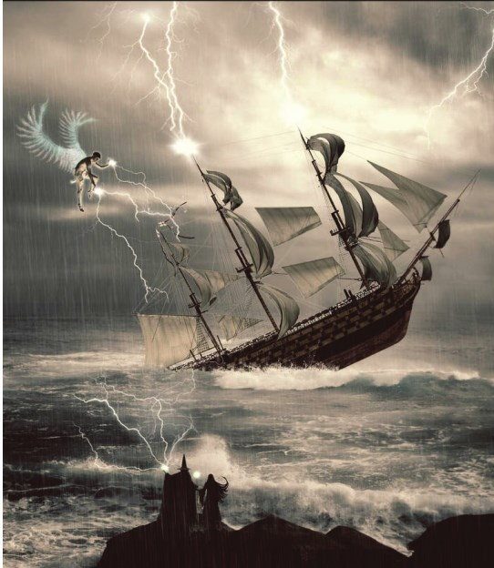
They lived in a cave made out of a rock; it was divided into several apartments, one of which Prospero called his study; there he kept his books, which chiefly treated of magic. By virtue of his art, he had released many good spirits from a witch called Sycorax who had them imprisoned in the bodies of large trees. These gentle spirits were ever after obedient to the will of Prospero. Of these Ariel was the chief.

Ariel took rather too much pleasure in tormenting an ugly monster called Caliban, because he was the son of his old enemy Sycorax. Caliban was employed

like a slave, to fetch wood, and do the most laborious offices; and Ariel had the charge of compelling him to these services.

With the help of these spirits, Prospero could command the winds, and the waves of the sea. By his orders they raised a violent storm, in the midst of which, he showed his daughter a fine large ship, which he told her was full of living

“Be not so amazed, daughter Miranda,” said Prospero; “there is no harm done. I have so ordered it, that no person in the ship shall receive any hurt. What I have done has been in care of you, my dear child. You are ignorant. Can you remember a time before you came to this cell? I think you cannot, for you were not then three years of age.”

beings like themselves. “Oh my dear

21

10th English_Unit_1.indd 21 28-11-2022 18:18:48

“Twelve years ago, Miranda,” “Heaven thank you, my dear father,” continued Prospero, “I was Duke of Milan, said Miranda. “Now tell me, sir, your

and you were a princess, and my only heir. I had a younger brother, whose name was Antonio, to whom I trusted everything; My brother Antonio being thus in possession of my power, began to think himself the duke indeed. The opportunity I gave him of making himself popular among my subjects awakened in his bad nature a proud ambition to deprive me of my dukedom: this he soon effected with the aid of the King of Naples, a powerful prince, who was my enemy.”

“Wherefore,” said Miranda, “did they not that hour destroy us?”

“My child,” answered her father, “they dared not, so dear was the love that my people bore me. Antonio carried us on board a ship, and when we were some leagues out at sea, he forced us into a small boat, without either tackle, sail, or mast: there he left us, as he thought, to perish. But a kind lord of my court, one Gonzalo, who loved me, had privately placed in the boat, water, provisions, apparel, and some books which I prize above my dukedom.”

“O my father,” said Miranda, “what a trouble must I have been to you then!”

“No, my love,” said Prospero, “you were a little angel that did preserve me. Your innocent smiles made me bear up against my misfortunes. Our food lasted till we landed on this desert island, since when my chief delight has been in teaching you, Miranda, and well have you profited by my instructions.”

reason for raising this sea-storm?”

“Know then,” said her father, “that by means of this storm, my enemies, the King of Naples, and my cruel brother, are cast ashore upon this island.”

Having so said, Prospero gently touched his daughter with his magic wand, and she fell fast asleep; for the spirit Ariel just then presented himself before his master, to give an account of the tempest, and how he had disposed of the ship’s company, and though the spirits were always invisible to Miranda, Prospero did not choose she should hear him holding conversation (as would seem to her) with the empty air.

“Well, my brave spirit,” said Prospero to Ariel, “how have you performed your task?”

Ariel gave a lively description of the storm, and of the terrors of the mariners; and how the king’s son, Ferdinand, was the first who leaped into the sea; and his father thought he saw his dear son swallowed up by the waves and lost. “But he is safe,” said Ariel, “in a corner of the isle, sadly lamenting the loss of the king, his father.

“That’s my delicate Ariel,” said Prospero. “Bring him here: my daughter must see this young prince. Where is the king, and my brother?”

“I left them,” answered Ariel, “searching for Ferdinand, whom they have little hopes of finding, thinking they saw

22

10th English_Unit_1.indd 22 28-11-2022 18:18:48

him perish. Of the ship’s crew not one is missing; though each one thinks himself the only one saved: and the ship, though invisible to them, is safe in the harbour.”

thought he was upon an enchanted island, and that Miranda was the goddess of the place, and as such he began to address her.

She timidly answered, she was no

Ariel then went to fetch Ferdinand. goddess, but a simple maid, and was

“O my young gentleman,” said Ariel, when he saw him, “I will soon move you. You must be brought, I find, for the Lady Miranda to have a sight of your pretty person. Come, sir, follow me.”

He followed in amazement the sound of Ariel’s voice, till it led him to Prospero and Miranda, who were sitting under the shade of a large tree. Now Miranda had never seen a man before, except her own father.
going to give him an account of herself, when Prospero interrupted her. He was well pleased to find they admired each other, but to try Ferdinand’s constancy, he resolved to throw some difficulties in their way: therefore advancing forward, he addressed the prince with a stern air, telling him, he came to the island as a spy, to take it from him who was the lord of it. “Follow me,” said he, “I will tie your neck and feet together. You shall drink sea-water; shell-fish, withered roots, and husks of acorns shall be your food.” “No,”

“Miranda,” said Prospero, “tell me what you are looking at yonder.”
said Ferdinand, “I will resist this” and drew his sword; but Prospero, waving his magic wand, fixed him to the spot where

“O father,” said Miranda, in a strange surprise, “surely that is a spirit. Lord! How it looks about! Believe me, it is a beautiful creature. Is it not a spirit?”

“No, girl,” answered her father; “it eats, and sleeps, and has senses such as we have. This young man you see was in the ship. He is somewhat altered by grief, or you might call him a handsome person. He has lost his companions, and is wandering about to find them.”

Miranda, who thought all men had grave faces and grey beards like her father, was delighted with the appearance of this beautiful young prince; and Ferdinand, seeing such a lovely lady in this desert place, and from the strange sounds he had heard, expecting nothing but wonders,
he stood, so that he had no power to move.

Miranda hung upon her father, saying, “Why are you so ungentle? Have pity, sir; I will be his surety. This is the second man I ever saw, and to me he seems a true one.”

“Silence,” said the father: “one word more will make me chide you, girl! What! An advocate for an impostor! You think there are no more such fine men, having seen only him and Caliban.” This he said to prove his daughter’s constancy; and she replied, “My affections are most humble. I have no wish to see a goodlier man.”

“Come on, young man,” said Prospero to the Prince; “you have no power to disobey me.”

23

10th English_Unit_1.indd 23 28-11-2022 18:18:48

Prospero had commanded Ferdinand “Fear nothing, my child,” said he; to pile up some heavy logs of wood. Kings’ “I have overheard, and approve of all sons not being much used to laborious you have said. And, Ferdinand, if I have work, Miranda soon after found him too severely used you, I will make you

almost dying with fatigue. “Alas!” said she, “do not work so hard; my father is at his studies, he is safe for these three hours; pray rest yourself.”
rich amends, by giving my daughter in marriage to you. All your vexations were but trials of your love, and you have nobly stood the test.

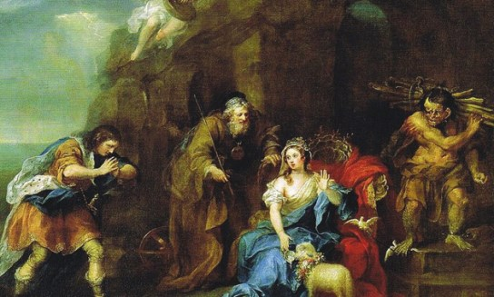
When Prospero left them, he called his spirit Ariel, who quickly appeared before him, eager to relate what he had done with Prospero’s brother and the

“O my dear lady,” said Ferdinand, “I dare not. I must finish my task before I take my rest.”

“If you will sit down,” said Miranda, “I will carry your logs the while.” But this Ferdinand would by no means agree to.

Prospero, who had enjoined Ferdinand this task merely as a trial of his love, was not at his books, as his daughter supposed, but was standing by them invisible, to overhear what they said.

Ferdinand inquired her name, which she told, saying it was against her father’s express command she did so.

And then Ferdinand, in a fine long speech, told the innocent Miranda he was heir to the crown of Naples, and that she should be his queen.

Prospero then appeared before them.
King of Naples. Ariel said he had left them almost out of their senses with fear, at the strange things he had caused them to see and hear. When fatigued with wandering about, and famished for want of food, he had suddenly set before them a delicious banquet, and then, just as they were going to eat, he appeared visible before them in the shape of a harpy, a voracious monster with wings, and the feast vanished away. Then, to their utter amazement, this seeming harpy spoke to them, reminding them of their cruelty in driving Prospero from his dukedom, and leaving him and his infant daughter to perish in the sea; saying, that for this cause these terrors were suffered to afflict them.

The King of Naples, and Antonio the false brother, repented the injustice they had done to Prospero.

“Then bring them here, Ariel,” said Prospero.

Ariel soon returned with the king, Antonio, and old Gonzalo. This Gonzalo was the same who had so kindly provided Prospero formerly with books and

24

10th English_Unit_1.indd 24 28-11-2022 18:18:48

provisions, when his wicked brother left Prospero now told them that their him, as he thought, to perish in an open ship was safe in the harbour, and the boat in the sea. sailors all on board her, and that he and

Grief and terror had so stupefied their senses, that they did not know
his daughter would accompany them home the next morning.

Prospero. He first discovered himself to the good old Gonzalo, calling him the preserver of his life; and then his brother and the king knew that he was the injured Prospero.

Antonio with tears, and sad words of sorrow and true repentance, implored his brother’s forgiveness and Prospero forgave them; and, upon their engaging to restore his dukedom, he said to the King of Naples, “I have a gift in store for you too;” and opening a door, showed him his son Ferdinand playing chess with Miranda.

Nothing could exceed the joy of the father and the son at this unexpected meeting, for they each thought the other drowned in the storm.

Before Prospero left the island, he dismissed Ariel from his service, to the great joy of that lively little spirit.


About the author

William Shakespeare (1564–1616) was born in Stratford-upon-Avon, England. He was an English
poet, playwright and actor. He is widely regarded as both the greatest writer in the English language and the world's pre-eminent dramatist. His surviving body of work includes 37 plays, 154 sonnets and two narrative poems, the majority of which he penned between 1589 and 1613.

The King of Naples was almost

as much astonished at the beauty and excellent graces of the young Miranda, as his son had been. “Who is this maid?” said

vThe play 'The Tempest' was written between 1610 and 1611.

he; “She is the daughter to this Prospero, vMany critics and historians

who is the famous Duke of Milan, of whose renown I have heard so much, but never saw him till now: of him I have received a new life: he has made himself to me a second father, giving me this dear lady,” said Ferdinand

“No more of that,” said Prospero: “let us not remember our troubles past, since they so happily have ended.” And then Prospero embraced his brother, and again assured him of his forgiveness.
believe it to be one of the last plays of William Shakespeare.
vIt is considered to be one of Shakespeare's well-written plays.
vIt is believed that the play 'The Tempest' was based on an actual wreck of a ship called Sea Venture off Bermuda that was headed to Virginia. There is a strong evidence that Shakespeare used elements of the story of the wreck.

25

10th English_Unit_1.indd 25 28-11-2022 18:18:49




4. Prospero ordered Ariel to bring
to his place.

a. Gonzalo tormenting (v) – making someone suffer c. King of Naples
b. Ferdinand d. Antonio

or worry a lot

dreadful (adj.) - extremely bad or unpleasant
duke (n) - a man of very high social rank in some European countries; a king
deprive (v) - to take something important or necessary away from someone

5. had provided Prospero formerly with books and provisions.

a. Antonio b. Ferdinand c. Gonzalo d. Antonio

6. The second human being that Miranda saw on the island was .

fatigue (n) - extreme tiredness

vexation (n) - worry or anger
a. Ariel
c. Ferdinand
b. Prospero d. Gonzalo

famished (adj.) - extremely hungry

voracious (adj.) - very eager for something

repent (v) - to be very sorry for something bad you have done.

A. Choose the correct answer


1. was the chief of all spirits.

a. Sycorax b. Caliban c. Ariel
d. Prospero

2. raised a dreadful storm.

B. Identify the character or speaker

1. She imprisoned the spirits in the bodies of large trees.

2. He was the chief of all spirits.

3. I was Duke of Milan, and you were a princess.

4. What a trouble must I have been to you then!

5. Now pray tell me, sir, your reason for raising this sea-storm?

6. I will soon move you.

7. I will tie you neck and feet together.

a. Caliban c. Miranda
b. Prospero d. Sycorax

8. I must finish my task before I take my rest.”

3. Miranda was brought to the island
years ago.

9. He repented and implored his brother’s forgiveness.

a. fourteen b. ten c. twelve d. five

26

10th English_Unit_1.indd 26 28-11-2022 18:18:49

C. Answer the following questions in one or two sentences.

1. Who were the inhabitants of the island?

2. What powers did Prospero possess?

3. Who was Caliban? What was he employed for?

4. Who were on the ship? How were they related to Prospero?

5. Why had Prospero raised a violent storm in the sea?

6. How did Miranda feel when her father raised the storm to destroy the ship?

7. What was Ariel ordered to do with the people on the ship?

8. Give two reasons why Miranda was so concerned about Ferdinand.

9. Why did Prospero set Ferdinand a severe task to perform?

10. How was Gonzalo helpful to Prospero when he left Milan?

D. Answer the questions in a paragraph of about 100 – 150 words.

1. Write a detailed character sketch of Prospero.

2. Narrate how Prospero made his enemies repent to restore his dukedom.

E. Rearrange the following sentences in coherent order

He ordered Ariel to torment the inmates of the ship.

Miranda was attracted by Ferdinand and had more concern towards him.

Prospero and Miranda came to an island and lived in a cave.

Prospero forgave them and restored his dukedom, Milan.

He raised a violent storm in the sea to wreck the ship of his enemies.

Prospero wanted to test Ferdinand and gave a severe task to perform.

Using his powers, Prospero released the good spirits from large bodies of trees.

The King of Naples, and Antonio the false brother, repented the injustice they had done to Prospero.

Ariel was instructed to bring Ferdinand, the prince of Naples to his cave.

Ferdinand was the second human whom Miranda had seen after her father.

27

10th English_Unit_1.indd 27 28-11-2022 18:18:49

