



vMarco Polo, Christopher Columbus, Ibn Battuta, Amerigo Vespucci, Xuanzang, Ferdinand Magellan, Bartolomeu Dias, Herodotus, Captain James Cook, Vasco Da Gama.

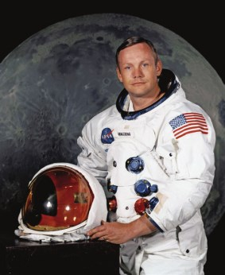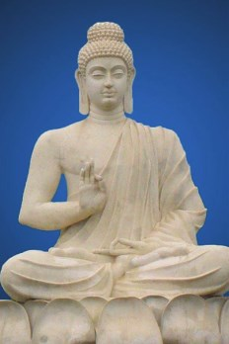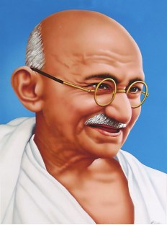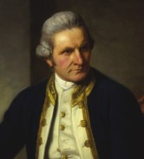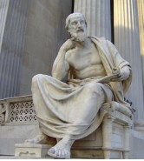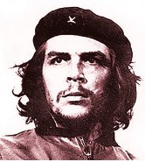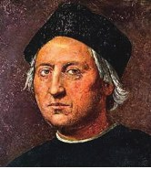

What is common among these individuals? Browse Internet or refer books and share some information about them.

vDiscuss, why it was considered as an adventurous and dangerous thing to travel in those days.

vMahatma Gandhi, Che Guevara, Guru Nanak and Gautama Buddha are some of the famous personalities and thinkers who made extensive journeys to understand life. Do you think journeys can be life changing?

vShare a memorable trip from your life.

vHave you ever been on an adventurous journey? If yes, share your experience.

v"That's one small step for a man, one giant leap for mankind." Neil Armstrong - Discuss

vHave you ever seen a bird making its first ever attempt to fly?

1

10th English_Unit_1.indd 1 28-11-2022 18:18:40

**1**

**His First Flight** *Liam O’Flaherty*

**Prose**

The young seagull was alone on his ledge. His two brothers and his sister had already flown away the day before. He had been afraid to fly with them. Somehow, when he had taken a little run forward to the brink of the ledge and attempted to flap his wings, he became afraid. The great expanse of sea stretched down beneath, and it was such a long way down – miles down. He felt certain that his wings would never support him; so he bent his head and ran away back to the little hole under the ledge where he slept at night.

fact, seen his older brother catch his first herring and devour it, standing on a rock, while his parents circled around raising a proud cackle. And all the morning, the whole family had walked about on the big plateau midway down the opposite cliff, laughing at his cowardice.

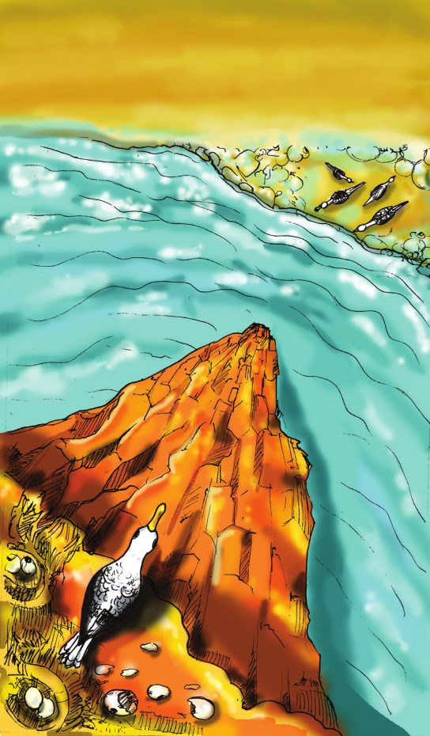The sun was now ascending the sky, blazing warmly on his ledge that faced the south. He felt the heat because he had not eaten since the previous nightfall. Then, he had found a dried piece of mackerel’s

Even when each of his brothers and his little sister, whose wings were far shorter than his own, ran to the brink, flapped their wings, and flew away, he failed to muster up courage to take that plunge which appeared to him so desperate. His father and mother had come around calling to him shrilly, scolding him, threatening to let him starve on his ledge, unless he flew away. But for the life of him, he could not move.

a. Why did the seagull fail to fly?

b. What did the parents do, when the young seagull failed to fly?

That was twenty-four hours ago. Since then, nobody had come near him. The day before, all day long, he had watched his parents flying about with his brothers and sister, perfecting them in the art of flight, teaching them how to skim the waves and how to dive for fish. He had, in

2

10th English_Unit_1.indd 2 28-11-2022 18:18:42

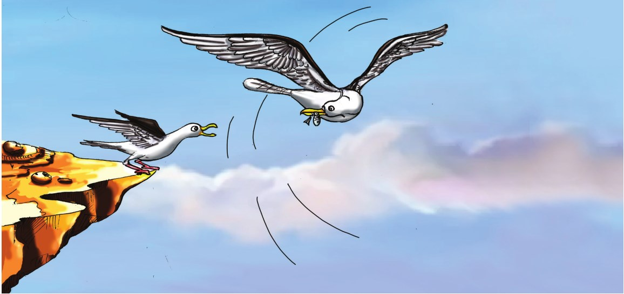

tail at the far end of his ledge. Now, there was not a single scrap of food left. He had searched every inch, rooting among the rough, dirt-caked straw nest where he and his brothers and sister had been hatched. He even gnawed at the dried pieces of eggshell. It was like eating a part of himself.

c. What was the first catch of the young seagull’s older brother?

d. What did the young seagull manage to find in his search for food on the

could he walk? There was no ledge, and he was not a fly. And above him, he could see nothing. The precipice was sheer, and the top of it was, perhaps, farther away than the sea beneath him.

He stepped slowly out to the brink of the ledge, and, standing on one leg with the other leg hidden under his wing, he closed one eye, then the other, and pretended to be falling asleep. Still, they took no notice of him. He saw his two brothers and his sister lying on the plateau dozing, with

ledge? their heads sunk into their necks. His

He then trotted back and forth from one end of the ledge to the other, his long gray legs stepping daintily, trying to

father was preening the feathers on his white back. Only his mother was looking at him.

find some means of reaching his parents She was standing on a little high without having to fly. But on each side hump on the plateau, her white breast

of him, the ledge ended in a sheer fall of precipice, with the sea beneath. And between him and his parents, there was a deep, wide crack.

Surely he could reach them without flying if he could only move northwards along the cliff face? But then, on what

thrust forward. Now and again, she tore at a piece of fish that lay at her feet, and then scraped each side of her beak on the rock. The sight of the food maddened him. How he loved to tear food that way, scraping his beak now and again to whet it! He uttered a low cackle. His mother cackled too, and looked at him.

3

10th English_Unit_1.indd 3 28-11-2022 18:18:43

e. What did the young bird do to seek the attention of his parents?

f. What made the young seagull go mad?

‘Ga, ga, ga,’ he cried, begging her to bring him over some food. ‘Gawl-ool-ah,’ she screamed back mockingly. But he kept calling plaintively, and after a minute or so, he uttered a joyful scream. His mother had picked up a piece of fish and was flying across to him with it. He leaned out eagerly, tapping the rock with his feet, trying to get nearer to her as she flew across. But when she was just opposite to him, abreast of the ledge, she halted, her legs hanging limp, her wings motionless, the piece of fish in her beak almost within reach of his beak.

He was not falling headlong now. He was soaring gradually, downwards and outwards. He was no longer afraid. He just felt a bit dizzy. Then, he flapped his wings once and he soared upwards.

He uttered a delightful scream and flapped them again. He soared higher. He raised his breast and banked against the wind. ‘Ga, ga, ga. Ga, ga, ga.’ ‘Gawlool-ah.’ His mother swooped past him, her wings making a loud noise. He answered her with another scream. Then, his father flew over him screaming. Then, he saw his two brothers and sister flying around him, soaring and diving.

Then, he completely forgot that he had not always been able to fly, and commenced to dive and soar, shrieking

He waited a moment in surprise, shrilly.

wondering why she did not come nearer, and then maddened by hunger, he dived at the fish. With a loud scream, he fell outwards and downwards into space. His mother had swooped upwards. As he passed beneath her, he heard the swish of her wings.

g. Why did the young bird utter a joyful scream?

h. Did the mother bird offer any food to the young bird?

Then a monstrous terror seized him

i. How did the bird feel when it started flying for the first time?

j. What did the young bird’s family do when he started flying?

He was near the sea now, flying straight over it, facing out over the ocean. He saw a vast green sea beneath him, with little ridges moving over it; he turned his beak sideways and crowed amusedly. His parents and his brothers and sister had landed on this green floor in front of him. They were beckoning to him, calling shrilly. He dropped his legs to stand on

and his heart stood still. He could hear the green sea. His legs sank into it. He nothing. But it only lasted a moment. The screamed with fright and attempted to next moment, he felt his wings spread rise again, flapping his wings. But he was

outwards. The wind rushed against his breast feathers, then under his stomach and against his wings. He could feel the tips of his wings cutting through the air.

tired and weak with hunger and he could not rise exhausted by the strange exercise. His feet sank into the green sea, and then his belly touched it and he sank no farther.

4

10th English_Unit_1.indd 4 28-11-2022 18:18:43

He was floating on it. And around him, **gnaw** (v)- to bite or chew something

his family was screaming, praising him, and their beaks were offering him scraps of dog-fish.

He had made his first flight.

**About the author**

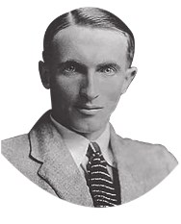

**Liam O'Flaherty** (1896–1984) was an

repeatedly

**trot** (v)- to run at a moderate pace with short steps

**precipice** (n)- a very steep side of a cliff or a mountain

**preening** (v)- cleaning feathers with beak

**whet** (v)- to sharpen

Irish novelist and short **plaintively** (adv.)- sadly, calling in a sad

story writer and a major figure in the Irish literary renaissance. He was a

founding member of the Communist Party of Ireland. A native Irish-speaker from the Gaeltacht, O'Flaherty wrote almost exclusively in English, except for a small number of short stories in the Irish language. He spent most of his time in travelling and lived comfortably and quietly outside the spotlight.

way

**swoop** (v)- to move very quickly and easily through the air

**beckoning** (v)- making a gesture with the hand or head to encourage someone to approach or follow.

**A. Answer the following questions in a sentence or two.**

1. How was the young seagull’s first attempt to fly?



2. How did the parents support and

**ledge** (n)- a narrow shelf that juts out from a vertical surface

**shrilly** (adv.)- producing a high-pitched and piercing voice or sound

**herring** (n)- a long silver fish that swims in large groups in the sea

**devour** (v)- to eat something eagerly and in large amounts, so that nothing is left

**cackle** (n)- a sharp, broken noise or cry of a hen, goose or seagull

**mackerel** (n)- a sea fish with a strong taste, often used as food

encourage the young seagull’s brothers and sister?

3. Give an instance that shows the pathetic condition of the young bird.

4. How did the bird try to reach its parents without having to fly?

5. Do you think that the young seagull’s parents were harsh to him? Why?

6. What prompted the young seagull to fly finally?

7. What happened to the young seagull when it landed on the green sea?

5

10th English_Unit_1.indd 5 28-11-2022 18:18:44

**B. Answer each of the following questions in a paragraph of about 100-150 words.**

1. Describe the struggles underwent by the young seagull to overcome its fear of flying.

2. Your parents sometimes behave like the young bird’s parents. They may seem cruel and unrelenting. Does it mean that they do not care for you? Explain your views about it with reference to the story.

**Parts of Speech.**



**Read the following sentences.**

**Set 1**

1. The young seagull uttered a joyful scream. *(adjective)* 2. The young seagull screamed with joy. *(noun)*

3. The young seagull screamed joyfully. *(adverb)*

**Set 2**

1. The young bird pretended to be falling asleep. *(verb)*

2. The young bird made a pretension of falling asleep. *(noun)*

3. The young bird made a pretentious posture of falling asleep. *(adjective)*

Note that in the Set 1, the adjective ‘joyful’ is changed to its noun form ‘joy’ and to its adverb form ‘joyfully’.

In the Set 2, the verb ‘pretend’ has been transformed to its noun form ‘pretension’ and to its adjective form ‘pretentious’.

We can transform a sentence by interchanging parts of speech without changing its meaning.

**C. Change the parts of speech of the given words in the chart.**

**Noun** **Verb** **Adjective** **Adverb**

exhaustion

widen

mad

perfectly

6

10th English_Unit_1.indd 6 28-11-2022 18:18:44



**D. Read the following sentences and** 4. The drinking water is supplied by

**change the form of the underlined words as directed.**

1. His family was screaming and offering him food. *(to adjective)*

2. The young seagull gave out a loud call. *(to adverb)*

3. The bird cackled amusedly while flying. *(to noun)*

4. The depth of the sea from the ledge scared the seagull. *(to adjective)*

5. The successful flight of the bird was a proud moment for the seagull’s family. *(to verb)*

**E. Use the following words to construct meaningful sentences on your own.**

lake to the city.

5. After Senchal lake, they visited

.

ii) Do you think they had a memorable and enjoyable school trip?

iii) Name a few places that you wish to visit with your classmates on a school trip.

iv) State whether the following statements are True or False.

1. As the sky was cloudy, they could get the glimpse of the Mount Everest.

2. The toy train covers 14 km in three hours.

3. Tiger hill has earned international

1. coward -

2. gradual -

3. praise -

4. courageous -

5. starvation -



fame for the best sunset view.

Your family has planned for a two-day trip to a tourist spot nearby in a reserved forest. Your father has no idea about what

safety measures and precautions to be

**F. *Here is a travelogue by the students of Government Girls Higher Secondary School, Pattukkottai after their trip to Darjeeling. Listen to the travelogue and answer the following questions.**

taken before you start. Enact a role-play on the above situation.

**Student 1:** As a son / daughter **Student 2:** As a father

**These would help you.**

i) Fill in the blanks with suitable words. 1. The students visited city.

2. is the third highest mountain in the world.

vImportant places to be visited

vFood and accommodation

vMode of transport

vNecessary clothes for two days

3. hill is 13 km away from Darjeeling.

*Listening text is on page 213

7

vFirst-aid kit, medicines etc. required if any.

10th English_Unit_1.indd 7 28-11-2022 18:18:44

**G. Here is a dialogue between a father and his daughter. Continue the**



**dialogue with at least five utterances and use all the clues given above.**

**Father:** Hi Mary, it has been a very long time since we went on a trip. Let’s plan one.

**Mary:** Yes, dad. I am also longing to go. Why don’t we plan one for this weekend?

**Father:** Sure. Tell me, where shall we go?

**Mary:** Some place nearby but for at least two days.

**Father:** Hmm… I think we should go to the reserved forest nearby.

**Mary:** Yeah. I’ve never been to a forest. I have seen it only on the TV and movies. A forest is a good choice!

**Father:** OK. If we are going to the forest, we must list out what we should carry with us for two days.

**Mary:** I think we should carry suitable

clothes like

**H. Read the following passage and answer the questions that follow.**

**BUNGEE-JUMPING**

Bungee Jumping is an activity that involves jumping from a tall structure while connected to a long elastic cord. The tall structure is usually a fixed object, such as a building, bridge or crane; but it is also possible to jump from a movable object, such as a hot-air-balloon or helicopter, that has the ability to hover above the ground. The thrill comes from the free-falling and the rebound. When the person jumps, the cord stretches and the jumper flies upwards again as the cord recoils, and continues to oscillate up and down until all the kinetic energy is dissipated.

Jumping Heights, located in Mohan Chatti village, in Rishikesh has been rated as one of the most preferred Bungee Jumping destinations in India at a height of 83 meters. It is the only place in India where Bungee Jumping can be done from

**Father:** What about the food? Do you have any idea, Mary?

a fixed platform. This is also India’s only fixed platform Bungee performed from a professional cantilever, to separate it from

**Mary:** Yeah. For food, I suggest

.

**Father:**

.

**Mary:**

entertainment parks, and create instead, an extreme adventure zone. The Bungee has been designed by David Allardice of New Zealand.

The Cantilever platform is built over a rocky cliff over-looking the river Hall, a tributary of River Ganges. Bungee-ing amidst the vastness of nature lends

. an absolutely breath taking experience.

8

10th English_Unit_1.indd 8 28-11-2022 18:18:44



Jumping Heights is well known for its safety measures and experienced staff. It costs around Rs 2500 per jump, a bit expensive, but totally worth the experience. The Bungee Jumping experience has been set amidst the astoundingly stunning landscape of Rishikesh. To Bungee jump, one must be at least 12 years and should weigh between

40-110 kg.

**Questions**

1. What is Bungee Jumping?

2. Can Bungee be performed from a movable object? How? 3. When do you think Bungee becomes thrilling?

4. What is the experience when one falls off the platform? 5. Where is the Bungee Jumping point located in India? 6. What is the minimum age to Bungee Jump?

**Advertisement**

An advertisement is an audio / visual / audio visual form of marketing communication to promote or sell a product, service or idea.

**An advertisement should include the following to make it attractive.**

1. Name of the product / brand / outlet.

2. Address with contact information and websites.

3. Appealing Images (visuals) of the Product / Service / Idea to be advertised.

4. Target demographics / audience / customers.

5. Feel-good discounts and offers.

6. Colourful Background.

7. Colourful and readable text.

8. Brief and catchy descriptions and benefits about the product.

9. Borders and lines to organize.

9

10th English_Unit_1.indd 9 28-11-2022 18:18:44

**Now look at the model advertisement given below**



**10**

**scoun**

**Di t**

**o**

**f r**

**t t**

**s uden s**



**%**

Offers / Discounts

Name

**More than 2000 books**

Target Audience

Product Description

**A collection of rare books Story books for children Fiction and Non-fiction Best-seller Collection Newspapers and Magazines**

**Stationery products**

**You name it!**

**We have it!**

Catchy Phrases

Appealing Visuals

**"There is no friend as loyal as a book."**

Address

**Main Road, Vallam, Thanjavur - 613 403**

Borders / Lines

**I. Prepare attractive advertisements using the hints given below.**

1. Home appliances – Aadi Sale – 20-50% - Special Combo Offers – Muthusamy & Co., Raja Street, Gingee.

2. Mobile Galaxy – Smart phones – accessories – SIM cards – Recharge – Free Power banks on Mobile purchase – No.1, Toll Gate, Trichy

**Report Writing**

A report is designed to lead people through the information in a structured way, and also to enable them to find the information that they want quickly and easily. It is a short, sharp, concise document which is written for a particular purpose and audience.

**Format of a report.**

vTitle of the report vReport Writer’s name vWhat…? *(name of the event)*

vWhen…? *(day and time of the event)*

vWho…? *(Chief guest,)*

vHow…? *(the details of the event and its impact etc.)*

vUse simple sentences in the Past Tense.

vWhere…? *(venue of the event)*

vWhy…? *(the purpose of the event)*

vBe brief.

vDo not exaggerate the event.

10

10th English_Unit_1.indd 10 28-11-2022 18:18:46

**Here is a sample report on the Annual Sports Day of a school. Observe the format and the language used.**

**Annual Sports Day**

*By Charan, X - C*

Government Higher Secondary School, Hosur, organized the Annual Sports Day on August 29, 2018. The event was to inculcate the spirit of sportsmanship and fondness for sports in children. Approximately 1,000 students participated in the track and field events. The program began with a prayer rendered by the school choir. Following this, the Headmaster delivered the welcome speech. The Sports Day was inaugurated by the Chief Guest, followed by march past, led by the school captain with a placard bearing the School’s name and motto. Then the much awaited track and field events began. As the events went by, the school campus reverberated with enthusiastic cheers from the spectators. Many new school level records were made in 50 metres, 100 metres, and 200 metres races. The merit and participation certificates were given away by the Chief Guest and Guests of Honour. In his speech, the Chief Guest praised the endeavours of the school. Then, the Headmaster proposed the vote of thanks. The event ended with the National Anthem.

**J. Write a report of the following events in about 100-120 words.**

1. ‘Educational Development Day’ was organized in your school on 15th July. The District Collector was the Chief Guest of the event. As part of the event, many competitions were held and the prizes were distributed to the winners and participants. It was a grand and successful event. Now, as the member of the organizing committee, write a report on the event in about 120 words.

2. You are the School Pupil Leader. You have been asked to write a report on the Inaugural Ceremony of English Literary Association of your school which was held recently. Write a report on the same in not more than 120 words.

3. You are the Coordinator of the Science Forum of your school. An event had been organized on account of National Science Day for the members of the forum. Now, write a report on the observance of “National Science Day” at your school.

11

10th English_Unit_1.indd 11 28-11-2022 18:18:46



**Modals**

**We have already learnt about Modals in Class IX. Now, let us revise.**

A modal verb is used to indicate modality (that expresses a speaker’s general intention) i.e. likelihood, ability, permission, request, capacity, suggestions, order, obligation, advice etc.

We use modals to show if we believe something is certain, probable or possible.

Modals are,

**can, could, may, might, will, would, shall, should, must & have to.**

Semi/Quasi modals are,

**ought to, need, dare & used to.**

Modals do not change with the person or number of the subject.

6. My father play badminton in the evenings when he was at college. *(past habit)*

7. You do as I say! *(command)*

8. I have another glass of water? (*request)*

9. Sibi has not practised hard but he

win the race. *(possibility)*

10. We preserve our natural resources. *(duty)*

**B. Rewrite the following sentences by rectifying the errors in the use of modals.**

1. Would I have your autograph?

2. I can be fifteen next April.

3. Take an umbrella. It should rain later.

4. The magistrate ordered that he might pay the fine.

5. Make me a cup of tea, shall you?

6. You may speak politely to the elders.

7. You will get your teeth cleaned at least once a year.

**A. Complete** **these** **sentences** **using** 8. We could grow vegetables in our

**appropriate modals. The clues in the brackets will help you.**

1. When I was a child, I climb trees easily but now I can’t. *(ability in the past)*

2. I win this singing contest.

kitchen garden but we don’t do it now.

9. Must I get your jacket? The weather is cold.

10. Could the train be on time?

*(determination)* **C. Read the dialogue and fill in the**

3. You buy this book. It is worth buying. *(advice or suggestion)*

4. Poongothai speak several languages. *(ability in the present)*

5. I swear I tell lies again. *(promise)*

12

**blanks with suitable modals.**

**Dad:** we go out for dinner tonight?

**Charan:** Yes, Dad. We go to a restaurant where I have some ice cream.

10th English_Unit_1.indd 12 28-11-2022 18:18:46

**Dad:** OK. Then, I be home by **D. Read the following dialogues and**

7 p.m. Mom and you be ready by then.

**Charan:** Sure. We . My friend told me that there is a magic show nearby.

you please take us there?

**Dad:** We not have time to go for the magic show, I suppose. If we have enough time left, we plan.

**Charan:** By the way, we inform our

**supply appropriate modals.**

**Student:** Can we leave our bags in the class during the break?

**Teacher:** Yes, you but arrange them neatly.

**Passenger:** My child is 6 years old. Do I have to buy him a ticket?

**Conductor:** Yes, you . It costs half of the price of an adult ticket.

gate keeper about our outing? **Vani:** Can we go for coffee after the

**Dad:** Yes, we so that he be aware we aren’t at home.

**Charan:** I call up Mom and tell her about our plan today?

**Dad:** You to. Otherwise, we might

meeting?

**Yoga:** No, I . I have to go home.

**Salesman:** When I receive my order?

**Customer:** I assure you sir, the order be delivered tomorrow.

be in trouble when she returns home. **Neela:** Do you think I should write

**Charan:** Hmm… by the time you come home in the evening, we be waiting for you. Hope you be late. Bye.

about my education background in the resume?

**Preethi:** Yes, you . You

get a better job.

**Imagine you have been to Thanjavur recently. Based on your experience and the data given below about Thanjavur, suggest and guide your friend who wishes to visit Thanjavur and places nearby, using modals in your sentences.**

**Trains towards Thanjavur**

• Uzhavan Express • Mannai Express

• Madurai Express

**Places to visit in Thanjavur**

• Brihadeeswarar Temple (Big temple)

• Museum

• Saraswathi Mahal (Library)

• Palace

**Places around Thanjavur**

• Thiruvaiyaru

• Kumbakonam • Kallanai Dam

• Poondi (Church)

• Manora Pattukkottai

**Unique Products of Thanjavur**

• Art Plates

• Paintings

• Bronze Statues

• Dancing Dolls

13

10th English_Unit_1.indd 13 28-11-2022 18:18:46

**E. Here are a few sentences already done for you. The clues given would be helpful to make more sentences on your own.**

1. I would suggest that you take the Uzhavan Express to Thanjavur from Chennai.

2. You will be more comfortable if you could book 3 tier A/C.

3. You could enjoy .

4. You should visit .

5. You mustn’t miss .

6. You can buy .

7. .

8. .

9. .

10. .

**Active and Passive**

In Class IX, we have already learnt about Active and Passive Voices. Now, we shall learn some more forms of the voice.

**Let us recall**

6. The militants were being taken to prison by the police.

7. His behaviour vexes me.

8. Rosy will solve the problem.

9. Our army has defeated the enemy.

When we give importance to what people and things do, we use active verb forms. When we give importance to what happens to people and things, we often use passive verb forms.

10. The salesman answered all the questions patiently.

**Passive Voice – Request**

Transitive verbs are followed by objects. Intransitive verbs do not take objects.

**F. Change the following sentences to the other voice.**

1. The manager appointed many office assistants.

2. You are making a cake now.

In Active Voice, a request begins with 'Please'. When we change a request from Active to Passive Voice, we should begin the sentence with ‘You are requested to’ in place of 'Please'. If the request is in negative form, the request in passive voice should begin with ‘You are requested not to’.

3. That portrait was painted by my grandmother.

4. Malini had bought a colourful hat for

**(e.g.)** 1. Please assemble in the ground. *(Active)*

her daughter.

5. They have asked me to pay the fine.

14

You are requested to assemble in the ground. *(Passive)*

10th English_Unit_1.indd 14 28-11-2022 18:18:46

**2.** Please do not use mobile phones here. *(Active)*

You are requested not to use mobile phones here. *(Passive)*

Passive Voice – **Advice**

**2.** No one has bought the tickets. *(Active)*

The tickets have not been bought. *(Passive)*

*(Add ‘not’ to the verb for nobody, none, no one)*

When we change an advice from Passive Voice – **Interrogatives**

active to passive voice, we should begin the sentence with ‘You are advised to’. If the advice is in negative form, it should begin with ‘You are advised not to’.

**(e.g.) 1.** Work hard *(Active)*

You are advised to work hard. *(Passive)*

When sentences are changed to Passive, they begin with a verb (in ‘Yes/ No’ questions) or with a question word followed by the verb (in ‘Wh’ questions).

**a. Questions beginning with Auxiliary verbs**

**(e.g.)** 1. Did he write a letter? *(Active)*

**2.** Do not eat junk food. *(Active)* Was a letter written by him?

You are advised not to eat junk food. *(Passive)*

Similarly, you can also use the following for other imperatives.

vYou are instructed to … You are instructed not to …

*(Passive)*

2. Is he watching us? *(Active)*

Are we being watched by him? *(Passive)*

**b. Questions beginning with ‘wh’ words**

**(e.g.)** 1. Who will accept this? *(Active)*

vYou are ordered to … You are ordered not to …

By whom will this be accepted? *(Passive)*

2. Who has arranged this meeting?

Passive Voice – **Omitting the agent**

*(Active)*

By whom has this meeting been

In the sentences beginning with arranged? *(Passive)*

someone/no one, omit the ‘agent’ (subject) in the passive voice.

**(e.g.) 1.** Somebody has taken away my book. *(Active)*

My book has been taken away. *(Passive)*

15

3. When will you finish the building? *(Active)*

When will the building be finished by you? *(Passive)*

*(the agent ‘by you’ is optional)* 4. How did they do this? *(Active)*

How was this done by them? *(Passive)*

*(the agent ‘by them’ is optional)*

10th English_Unit_1.indd 15 28-11-2022 18:18:46

**G. Change the following into passive voice.**

4. They offered the job to Venkat.

a.

1. Please call him at once.

2. How did you cross the river?

3. No one is borrowing the novels from the library.

4. Will you help me?

5. Go for a jog early in the morning.

b.

5. The boss showed the new computer to Kaviya.

a.

b.

6. Why have you left your brother at home?

**I. Rewrite the following passage in passive voice.**

7. Nobody should violate the rules. A few days ago, someone stole

8. Someone has to initiate it immediately.

9. Have you invited Raman to the party?

10. Please do not walk on the grass.

11. Cross the busy roads carefully.

12. When will you book the tickets to Bengaluru?

**H. In the following sentences the verbs have two objects namely Direct and Indirect objects. Change each of the following sentences into two passives using direct object as the subject in one and indirect in the other.**

1. John gave a bar of chocolate to Jill.

a: Jill was given

b: A bar of chocolate was given

2. Pragathi lent a pencil to Keerthana.

a.

b.

Ambrose’s motorbike. Ambrose had left it outside his house. He reported the theft to the police. The police told him that they would try to find his motorbike. This morning, they found his motorbike. The police called Ambrose to the police station. The thieves had painted it and then sold it to someone else. The new owner had parked the motorbike outside a mall when the police found it. After an enquiry, the police arrested the thieves.

**J. Write a recipe of your favourite dish in passive voice. Remember to list out the ingredients of the dish you have chosen and their quantity. Use simple present tense to write your recipe.**

**K. Write a report of an event held at your school using passive voice. Use simple past tense to narrate the event.**

3. Sudha told the truth to her friend.

a.

b.

16

10th English_Unit_1.indd 16 28-11-2022 18:18:46